
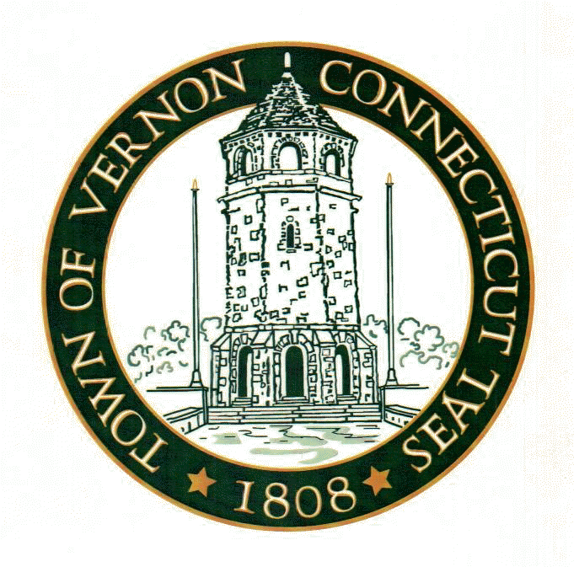



3rd Annual
Fox Hill Cyclocross
Sunday, October 20th , 2002
Held Under US Cycling Federation Permit (Permit # Pending)

Promoters: Team Horst Engineering (with inspiration from Team Frank), Connecticut Yankee Bicycle Club, and Vernon Cycle

Sponsors: Vernon Cycle www.vernoncycle.com
Horst Engineering & Manufacturing Co. www.horstengineering.com
Richard Sachs Cycles www.richardsachs.com
Voler Team Apparel www.voler.com
Town of Vernon

Where: Henry Park, Vernon, CT

Races: Rain, Snow, or Shine
Race | Time | Distance | Places | Prize List | Cost*
“C”Citizen | 10:30am | 30' + 1 lap | 3 | TBD | $15.00
Women | 11:30am | 45' + 1 lap | 5 | Cash | $15.00
JR’s | 11:30am | 45' + 1 lap | 3 | Cash | $15.00
M35 | 11:30am | 45' + 1 lap | 3 | Cash | $15.00
“B” | 12:30pm | 45' + 1 lap | 3 | TBD | $15.00
“A” | 2:00pm | 60' + 1 lap | 10 | Cash | $15.00

* There is no late fee ☺! $2.00 USCF Insurance surcharge is already included in the cost.
* Promoter Reserves the right to combine fields and alter the prize list.
* Registration opens at 8am and closes 20min prior to each event.

Formula for Cash Prizes: Based upon the Total number of entries in the “A” field(n) for “A” race only.
“A” = 1st (1.1n), 2nd (n), 3rd (0.9n), 4th (0.8n), 5th (0.7n), 6th (0.6n), 7th (0.5n), 8th (0.5n), 9th (0.5n), 10th (0.5n)
Women = $45, $35, $30, $20, $15
Jr’s/M35 = $30, $25, $20

The parcours: The course will climb and descend the infamous Foxberg several times. Enjoy the fine view from the top. There will be a lot of grass, a little asphalt, tight turns, and several dismounts.

Directions: I-84 (West from MA/East from Hartford) to Exit 67 (Vernon/Coventry). Take a right (MA) or a left (Hartford) off the exit onto Rt. 31 (Mile Hill Rd). Travel .4 miles. Take a left onto Rt. 30 (Hartford Tpke.) at the first light. Travel .2 miles. Turn Right onto South Street. Travel .5 miles. Turn right onto Henry Park Way. Follow signs.

* Register at www.BikeReg.com or make checks payable to GS Fiorenzo Magni and send a standard 2002 USCF Entry to:

* Fox Hill Cyclocross, C/O A. Z. Wenzel, 31 Nutmeg Court, Middletown, CT 06457

* For additional information please contact Arlen Wenzel @ 860.346.3387 azwenzel@earthlink.net or Vernon Cycle @ 860.872.7740

